Group Report

## Summary:

* Introduction.
* What went well (highlights).
* What did not go well / problems and issues (lowlights).
* How well the team worked together (self-reflection of progress).
* What you learned whilst doing the coursework.
* What you might do differently next time.
* Other info.
* Peer review.

## Introduction

In this report, the organisation, planning and execution of the Clue! Project being developed for the client Watson games will be examined and discussed, as well as talking about what lessons were learnt and how best to apply them in the future. Furthermore, we will be talking about the problems our group faced outside of programming and how it affected our work.

## What went well

The team's strongest area was in organising and documentation. We made sure each meeting was planned and confirmed a few days in advance, and we would nominate someone to write the minutes document for each meeting. Furthermore, we undertook market research, wrote and planned sprints and its documentations, created a Gantt chart using specialised software and design documents. Due to this, each member of the team was always aware of project progress, outstanding tasks, future goals and plans, and who was assigned to what areas of the project. The Gantt Chart we used to plan our project can be seen below.

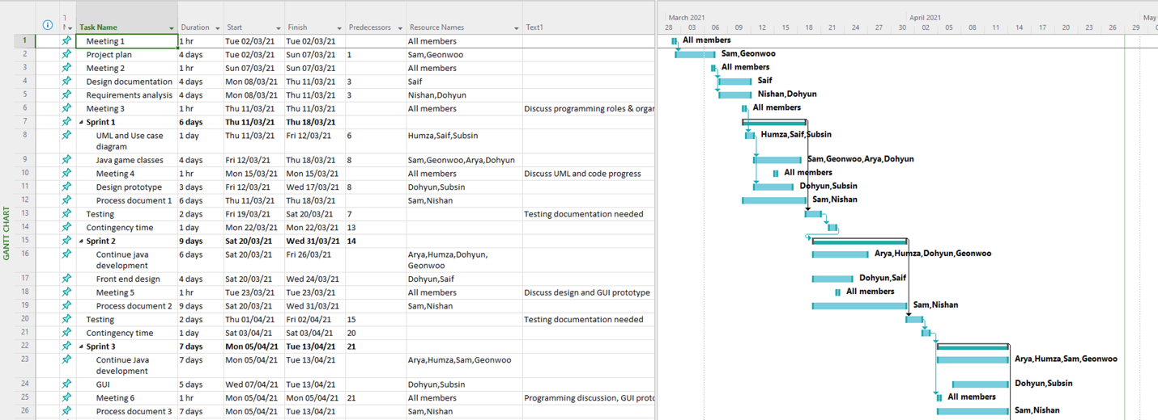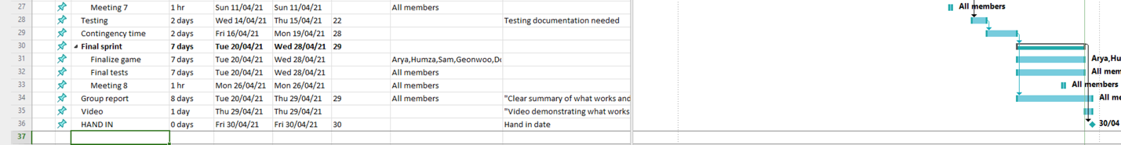

We did have a couple of iterations to this Gantt chart during the project. This was because we needed to make alterations as we progressed through tasks. Sometimes we would go over the due date for certain things so other tasks would get moved back. We added a few more formal meetings into the plan as we went as well after realising some of the coding complexities that needed extra attention and discussion. We made a good decision with adding contingency time between our sprints at the beginning of the planning stage. This allowed us to have a couple days extra between coding sprints to gather ourselves and documentation. Using Microsoft project, we were able to easily assign tasks to different group members (as seen under ‘Resource names’) which helped a lot when people needed to check what they should each be working on. The program also allowed us to easily add, remove and change tasks without messing up everything that followed.

Another strong point of our group was realising each other's weakness and working with each other to cover these weaknesses. Several of our members were weak with Java. Those who were stronger organised several sessions outside of our allocated project times. We worked with each other to cover weaknesses and used our teamwork to further highlight our strengths. This allowed everyone to be working on something they were relatively comfortable with.

Finally, our utilization of third-party software to work together over long distances, organise ourselves and plan out our work was useful in helping to finish our work. Due to the current pandemic, several of our members were stuck in other countries. Saif, Subsin and Nishan-Bose were all either outside of England or lived too far to conceivable make their way to the University of Sussex. Two other members, Humza and Arya were also outside of England for much of the time. Therefore, for us to even be able to work together with any meaningful cohesion required expert utilization of third-party communication software. We created various chat groups and a discord to help organize ourselves. Furthermore, several different rooms were created in Discord in order to properly organise our work by class and department. As mentioned before, we also used Microsoft project which was used frequently as a reference to current tasks needing completion.

## What did not go well / problems and issues

One initial problem that became clear as our group started to collaborate was that our group was over stacked with people who either specialised in graphical work, paperwork and theory, and those who were confident in coding were more experienced with python than with Java. This was a problem as it would be extremely difficult and inefficient to write the game using Python. As everyone in the group had at the very least a passing experience with Java, our group was far from the required experience. During one of the earlier meetings, we had discussed potentially using Python over Java. We ended up staying with java due to the more general experience everyone has had with it meaning more people would be able to help with programming.

Another problem that became evident later was during the project was the failure to set realistic goals and how to properly achieve them. Whilst our planning and organisation of tasks was very good, our ability to follow through with our goals and targets severely hindered our ability to finish the project. For example, whilst we planned out several of the classes needed and assigned the required timeframe for each task, many members struggled to finish their tasks in time either due to external reasons such as family problems, inexperience with Java, or several other factors which affected them and their ability to finish the tasks.

We were also overconfident in our ability to finish the project. This was due to our large group number however this led to another problem, although an unexpected one. This problem was, for lack of a better phrase, having too many chefs. The large number of members meant that we had to spend more time than we wanted on getting our code to work with each other, and for our graphical designs to match each other's art-style so that the game did not look like a patchwork of different graphical assets. Unfortunately, this took up a lot of our time and severely affected the final product we produced.

## How well the team worked together

Due to circumstances that will be discussed later in the report our group was forced to come together very late. We communicated with each other as soon as possible and set to work once several avenues of communication had been established. We quickly established each other's strengths and weaknesses and set out to plan and create our game. Three members added to the group did not participate. All members attempted to participate as much as they could and worked with each other to accommodate their weakness and highlight their strengths. Furthermore, several members were struggling with other coursework, or had external problems that they had to deal with, and they communicated to the group clearly so that their work could be covered for a short while by other members who were available.

Towards the end of the project, the informal lab meetings massively helped productivity as we could bounce ideas, issues and opinions off each other as we became more comfortable. During this period, we managed to get a lot of the final tasks completed as well as some which had been postponed previously.

In short, all members who participated worked together well and everyone put a proportionate amount of effort and energy.

## What you learned whilst doing the coursework

One of the main lessons learnt was that having more members does not equate to better productivity.   
Indeed, it seems that there is a diminishing return on what can be achieved with more members, and in our case, it increased our workload as we needed to spend more time balancing and combining our code and designs so that they worked as intended. Having more members also resulted in slightly harder management between members. Some much smaller tasks such as early documentation was sometimes spread between two or more members to try and spread workload during the project. Lack of communication between these people would often result in assumption that another member was completing a task, when this wasn’t the case.

Furthermore, we learnt that each team needs a balanced blend of theoretical knowledge and practical skills. As mentioned earlier our group was more weighted towards theory and graphical design than programming.

We also learnt that proper use of communication is important as our project would be in a much worse state had we all not communicated to each other properly.

In addition, we learnt that proper use of third-party software is important in ensuring that a project is finished on time, and can help in planning, organising, communicating and designing during a project.

Finally, we learnt that we needed to set more realistic goals as many members struggled to finish their tasks in time and struggled with tasks that were too large or too complex.

## What we might do differently next time.

* Work in smaller but more specialised groups that can fully utilize their time and skills on the task at hand
* Create teams with varied skills and expertise instead of “putting all your eggs in one basket”
* Set smaller and less complicated tasks.

## Other information

Unfortunately at the outset, our group was late getting started meaning we lost a lot of time. Our members were originally from several different groups that fell apart because of too many of the other members not participating in the project. This severely affected our ability in producing a quality game within the required timeframe

Several members have had to work from outside the country, Saif, Subsin and Nishan-Bose were all either outside of England or lived too far to conceivable make their way to the University of Sussex. Two other members, Humza and Arya were also outside of England for most of the time.

## Peer review

|  |  |
| --- | --- |
| Satti, Humza Z | Score: 27.5 |
| Samuel J | Score: 27.5 |
| Chen, Ziyi | Score: 0 |
| Lim, Geonwoo | Score: 27.5 |
| Sriprasert, Subsin | Score: 27.5 |
| Dohyun Lee | Score: 27.5 |
| Deivendranbose, Nishan‐Bose | Score: 27.5 |
| Diznabi, Arya | Score: 27.5 |
| Fang, Chengzhe | Score: 0 |
| Harris, Joshua | Score: 0 |
| Zuqaili, Saif MY | Score: 27.5 |